Plattsburgh Beekmantown
Hornets vs. Eagles
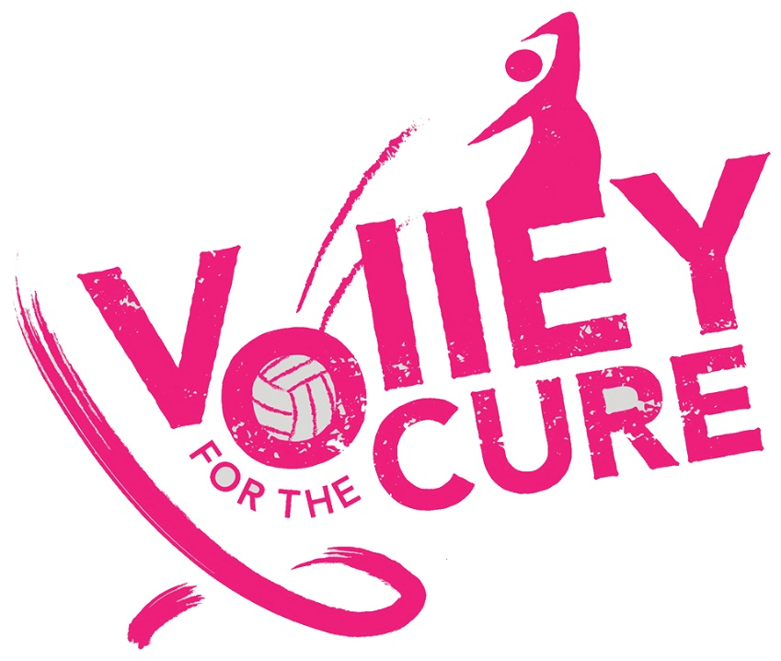
Monday
Oct. 15, 2018
@ PHS Gymnasium
JV Game @ 4:30
Varsity @ 6 p.m.

Purchase a $15 Volley for the Cure T-shirt to help us:

50/50 raffle during both games
Concession stand will be available.
Donations will be collected at the door
Dress in PINK to support awareness.
The person wearing the MOST Pink will win a prize!

